Chapter 3, Problem 47.

Rework Prob. 3.19 using mesh analysis.

Chapter 3, Problem 3.19

Use nodal analysis to find V₁, V₂, and V₃ in the circuit in Fig. 3.68.

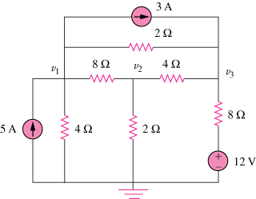

Figure 3.68
For Prob. 3.47.

